A short overview of the new EpiData Analysis (2018)

Use EpiData Analysis when you want to do simple or comprehensive data management and basic descriptive statistical analyses. Extended statistical modelling must be done with other software such as R, Stata etc. Operating systems supported: Linux, Windows and Machintosh.

The final EpiData Analysis Classic developed from 2004-2014 is version 2.2 rel 3 (Build 187) is still available from www.epidata.dk. The classic version will not be further updated.

The revised EpiData Analysis was first released as v1.0 with this functionality:
- Comprehensive data management, data verification, checks and documentation features. Data may be verified (validate and check data)
- Read & write several data formats (epx/epz, encrypted epx/epz, csv, Stata) and export DDI-v3.1. All character handling is UTF-8 compatible. Results may be saved in text or html format. The previous rec+chk format may be read, but not written.
- Analysis commands in v1.0: count, frequencies, means. Following release of v1.0 collapsing of data (aggregate), crosstables, table estimation and graphs will be implemented. See www.epidata.dk for news and updates.
- Function is validated with several batch tests for datasets up to 125000 observations and 250 variables. But also related datasets and encrypted projects with user logging.

Download and install from www.epidata.dk for Linux, Windows or Mac . EpiData software will not interfere with the setup of your computer, but for most computers you need administrator rights. The software is also provided as zip/tgz for direct unpacking.

The interface of Analysis. After reading a file (File menu) you can see the datasets with function key F2, variables with F3, history F7, editor F5 and databrowser with F6. Notice the help menu (opened here)
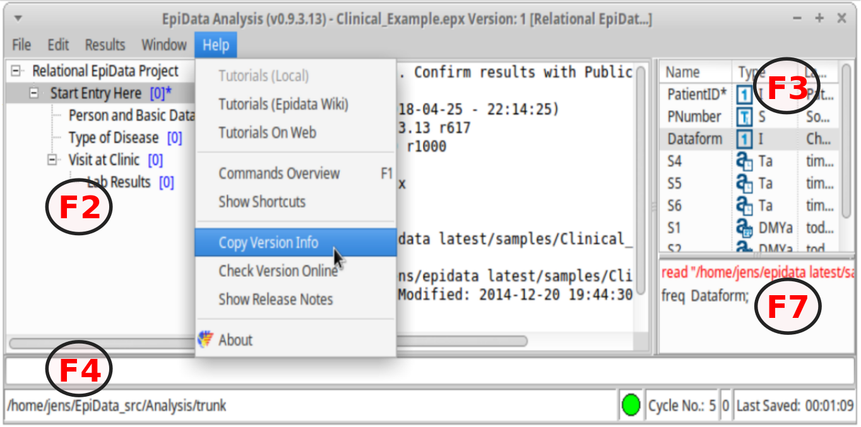
License The program as such cannot be sold for money or service value. It is absolutely free. There can be NO charge taken by a web site for downloading of EpiData. Distributed according to a CC license.

Flowsheet A simplified flowsheet of how EpiData Analysis is working is shown below. Blue parts are optional, black parts are in memory and red parts saved permanently to disk. Note that the programme always works with a copy of data. It is good practice to use a pgm documenting change or analysis and save updated data and pgm files under a name. All issued commands are saved to the file commandlog.pgm (one copy in each active folder).

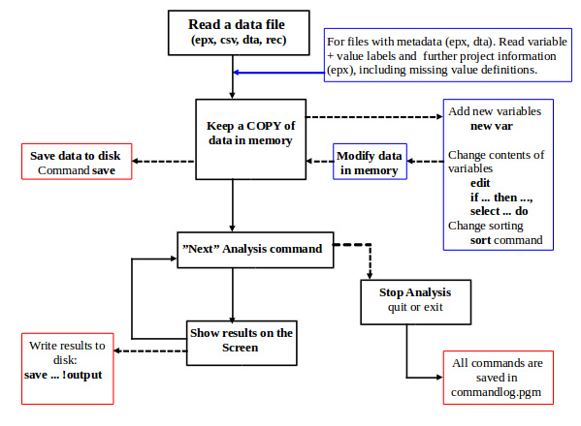
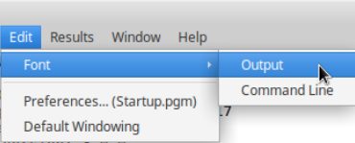
Change font size or colours. Find this in the main menu under “Edit” .
If you want to make a permanent change save your choices to the startup.pgm
Edit startup.pgm via the "preferences", which will open the editor, where you could easily insert all set options and see choices.

An example is to change from the default text output format to html.

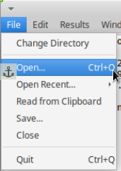
To execute a command write in the editor or in the command line, then run the command by hitting "enter" or "mark" to run in the editor.

Start to read a datafile via the menu first with “Read Data” in the file menu to the left on your screen and point your disk selector to where you installed the EpiData Analysis programme in the subfolder “samples”.

Here the file "Clinical Example.epx" was read and after that the command "list ds" issued, which will show the following.

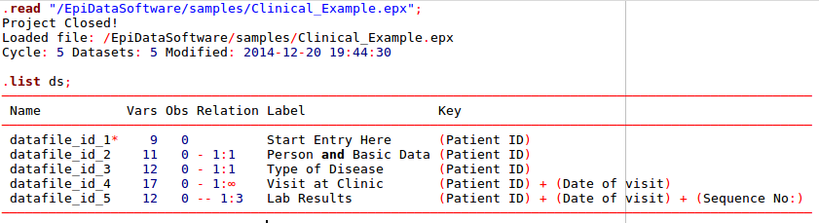
(The output was copied to the editor to show syntax highlight)
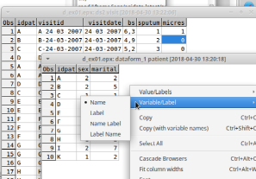
Browse data Every time you open a data file it is good practice to view the data.

Use the browse command or press (F6) key and you will see the data in a grid. Browse opens a new copy of the data at the time of issuing the browse command.
With options when you start browse you may arrange or change the view, e.g. value labels or values or changing the caption as shown below.

Edit data, structure or content.
In analysis several commands exist, which will create, edit or modify datasets or variables.
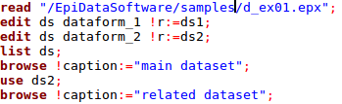
Here just one (edit ds) is shown, look in the help file for options, variations and suggestions.

The commands show here will read a project file, rename the datasets, show the first dataset in a browse, change to the second dataset (use) and show this in a browser.

Show a table of frequencies.
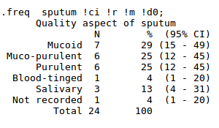
Write "freq" in the command line (F4) and then in the variables window (F3) doubleclick on one variable and then press the enter key.

You will see that the name is copied to the command prompt. If you now press enter, the frequency table will be shown.

Then in history (F7) click on the freq , which will copy to the command line.

If you add !r, !ci to the command, then percentages and confidence intervals are shown to the right of the numbers of observations. With !m any missing will be included and with !dx (here x is zero !d0) there will be no decimals on the percentages. Default is 1 decimal.

You could also press UpArrow in the command line to use the previous command in history.

Showing means of age by time
Write instead in the command prompt (F4) now "Means", choose the variable bs (F3) and hit enter. After seing the result press again (F4) and "UpArrow", which will show the command again. Add to the end of this !t !by:= sputum !t

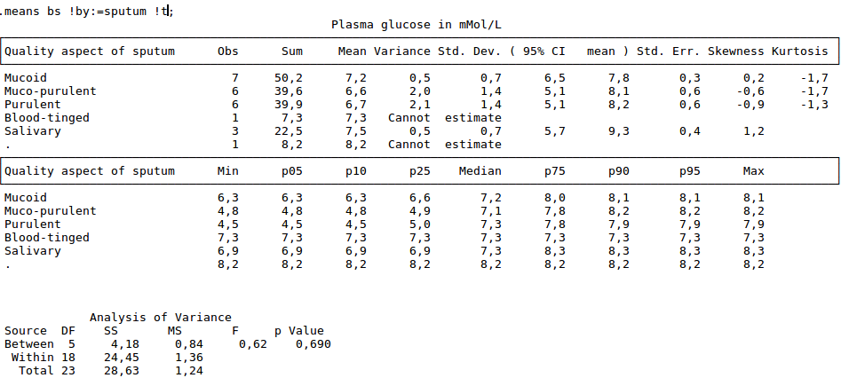
Get further acquainted:
- Resize the program by dragging in sides or the separator between output window (viewer) and right side parts. Save current position in window menu. ”Save Window Position”
- Try to change the active folder via the file menu and notice that the commandlog.pgm is left behind and a new one started in the new folder. .
- Run commands from within the editor and save pgm files for future use.
- Try the help menu. If you are connected to internet you can activate ”Check Version” part which will compare your version with the most updated on on www.epidata.dk
Further introduction
- In a specific project do specific datamanagement and soon you will get more experience. Find inspiration in example pgm and the document on "how to upgrade previous pgm files - which is also installed in the local documentation folder.

Support

If you find errors or bugs when using the program or have suggestions for improval please discuss with the EpiData-list available at http://lists.umanitoba.ca/mailman/listinfo/epidata-list

Suggested citation of EpiData Analysis program:

(to be added later)

Funding and acknowledgements.
An updated list of attained funding is available at Http://www.epidata.dk/funding.htm. Further credits and acknowledgements at: Http://www.epidata.dk/credit.htm . International translations made to several languages, see Http://www.epidata.dk For donations to further development see help file or send an e-mail to info@epidata.dk. Isolated parts of source code based on freeware and shareware components. Please consult credit pages.

Disclaimer
The EpiData Analysis software program was developed and tested to ensure fail-safe analysis and documentation of data. We made every possible effort in producing a fail-safe program, but cannot in any circumstance be held responsible for errors, loss of data, work time or other losses incurred by or in relation to the program.

